# Problem Statement

# TASK-2:

# Website:

[**http://zero.webappsecurity.com/**](http://zero.webappsecurity.com/) We have set up a real life-like web application in the form of an online bank portal.

# My task:

Your task is to test this website and find all possible vulnerabilities and loopholes in it. To do so you can use the automatic vulnerabilities scanner “Netsparker” which was taught to you in the session of Automatic Vulnerability Scanner. If you want you can download it using this link:

# Finding Vulnerabilities In:

https://drive.google.com/drive/folders/193Ha6QVU9Joh-rhhOvH78HrTNO1OgaMx?usp =sharing You have to find 3 critical vulnerabilities. No matter if they are taught to you or not. Now just choose any 1 amongst that 3 and write a report in your own language. If you are using Netsparker you can use the report already generated by software but make sure you do not have to copy it. You have to then submit the report generated by you.

# Solution:

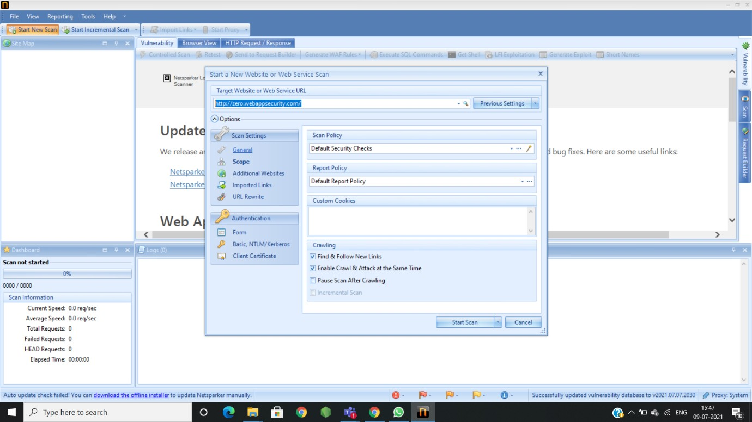

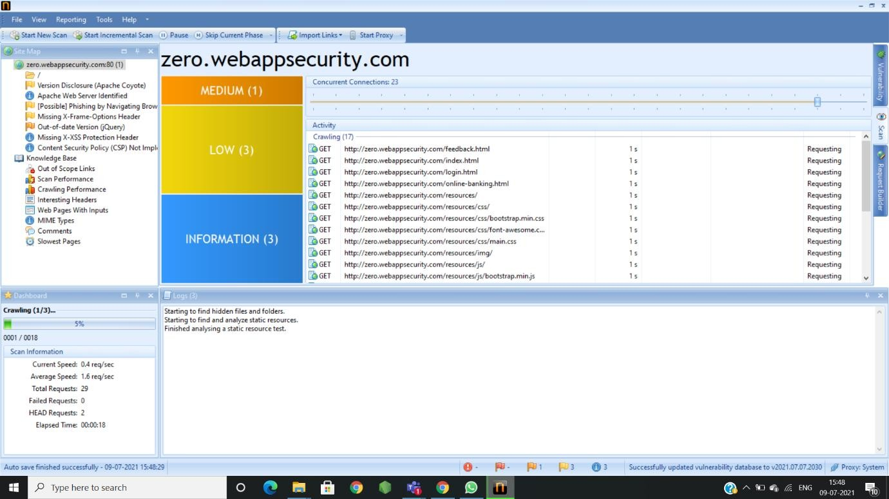

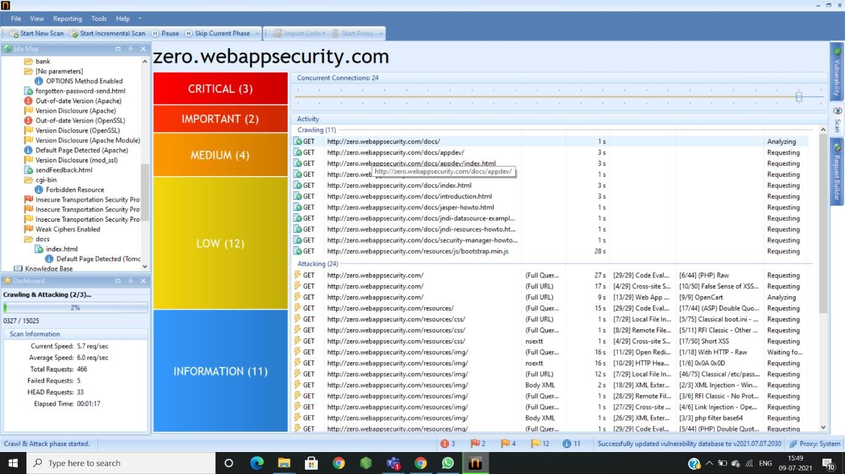

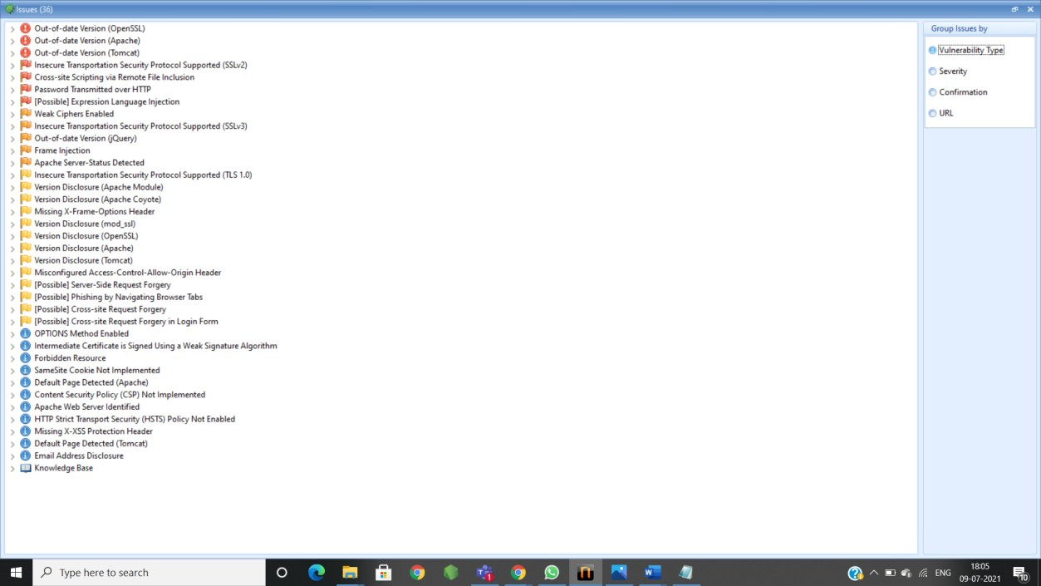

**Report from Netsparker**

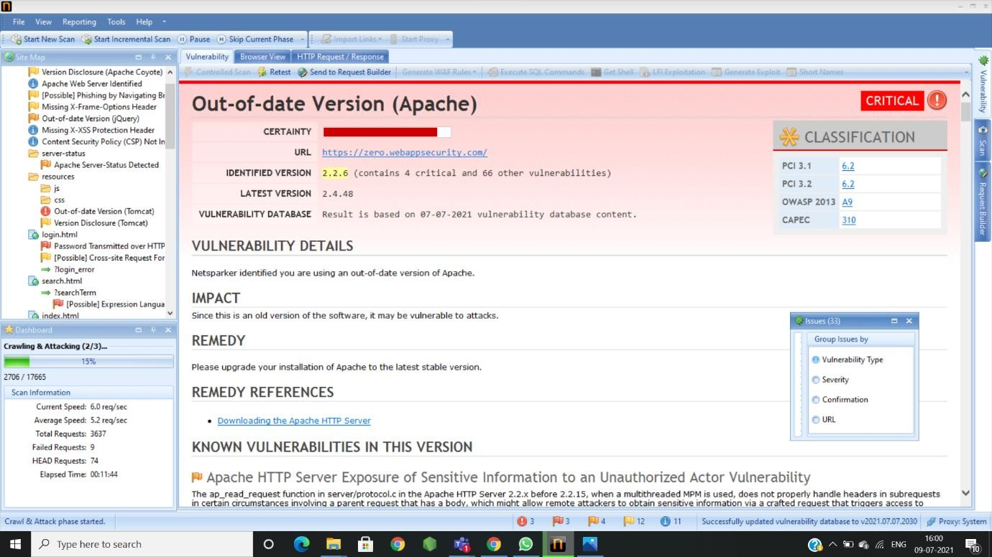

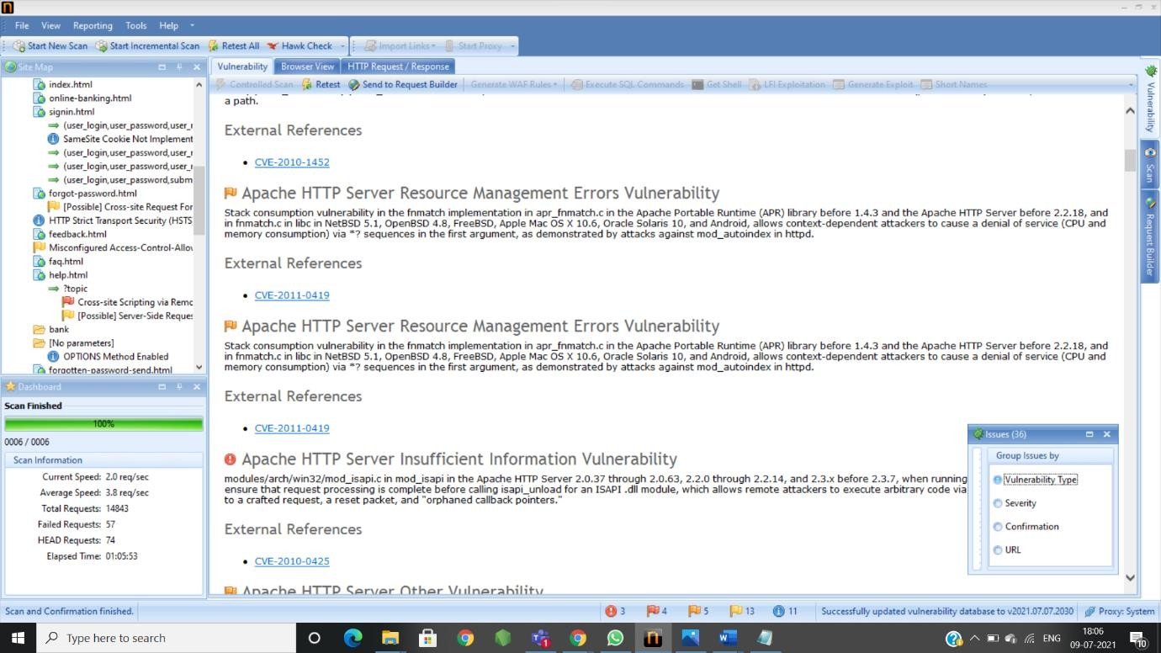

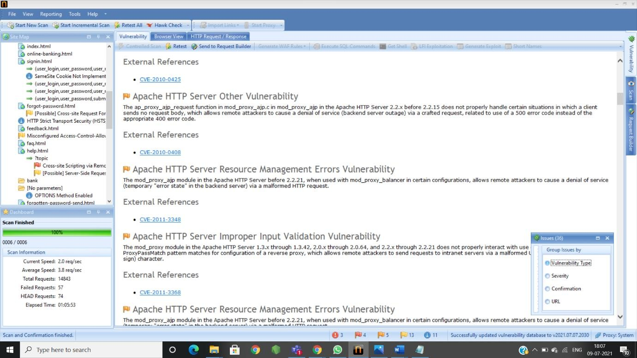

MY REPORT:

Title:: -Out-Of-Date Version(Apache)

Domain::- <https://zero.webappsecurity.com/>

Vulnerability Information:: -Apache version is out dated that is using by WebappSecurity.

Impact::--It may be vulnerable to attacks because of its old version:2.2.6

* your systems/devices will be more vulnerable to randomware attacks, malware and data breaches.
* Some times it might be the back door for your systems/devices/servers for hackers .
* Hackers can steal yours user details because of its vulnerability.
* Solution::-It is recommended to use the latest version(2.4.8)

Please Upgrade your apache to latest version of Apache otherwise you will face

above mention problems.